**Final Project:**

Project Name: practice-datadriven-amazon-msazure

Steps to run a project using azure pipeline:

1)Create a project(ex:final-project-amazon) in azure devops organization.

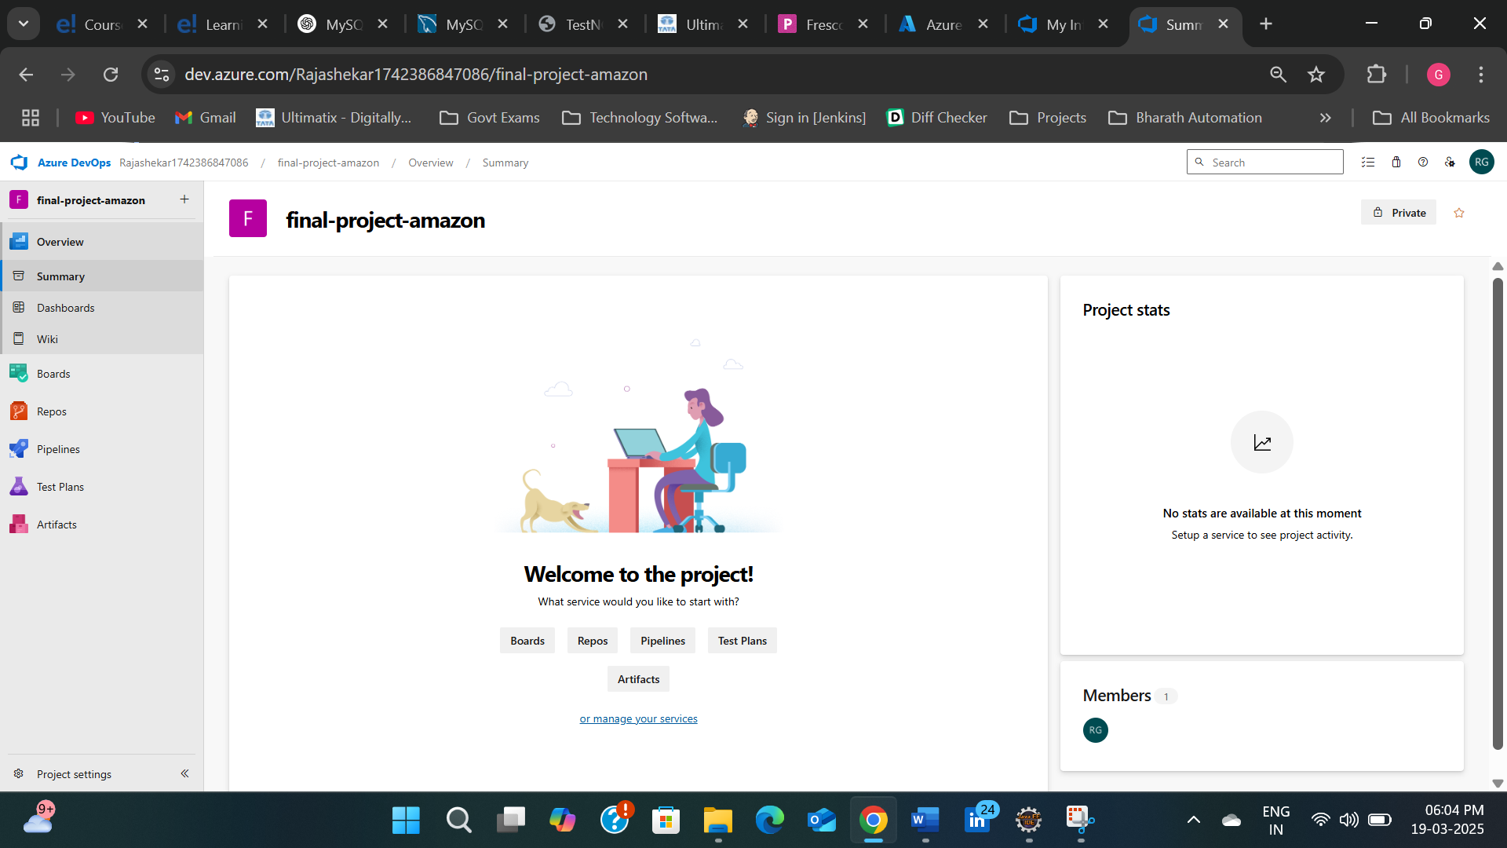

2)Go to Repos->Files and copy the https request of push an existing repository from command line(as we have the project in our local machine).

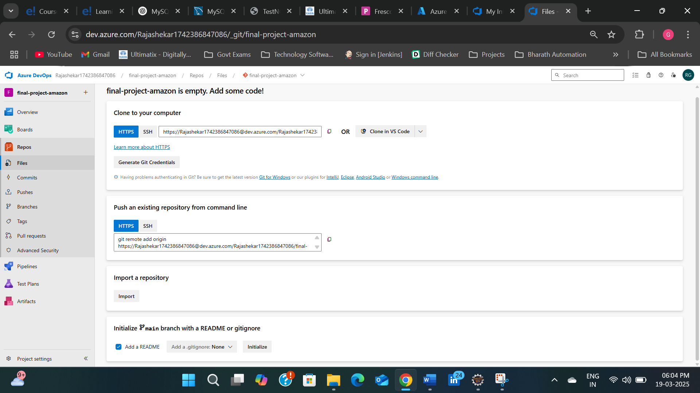

3)Navigate to project location in our local machine and open bash.

4)Perform Git commands to push project from local machine to project in azure devops

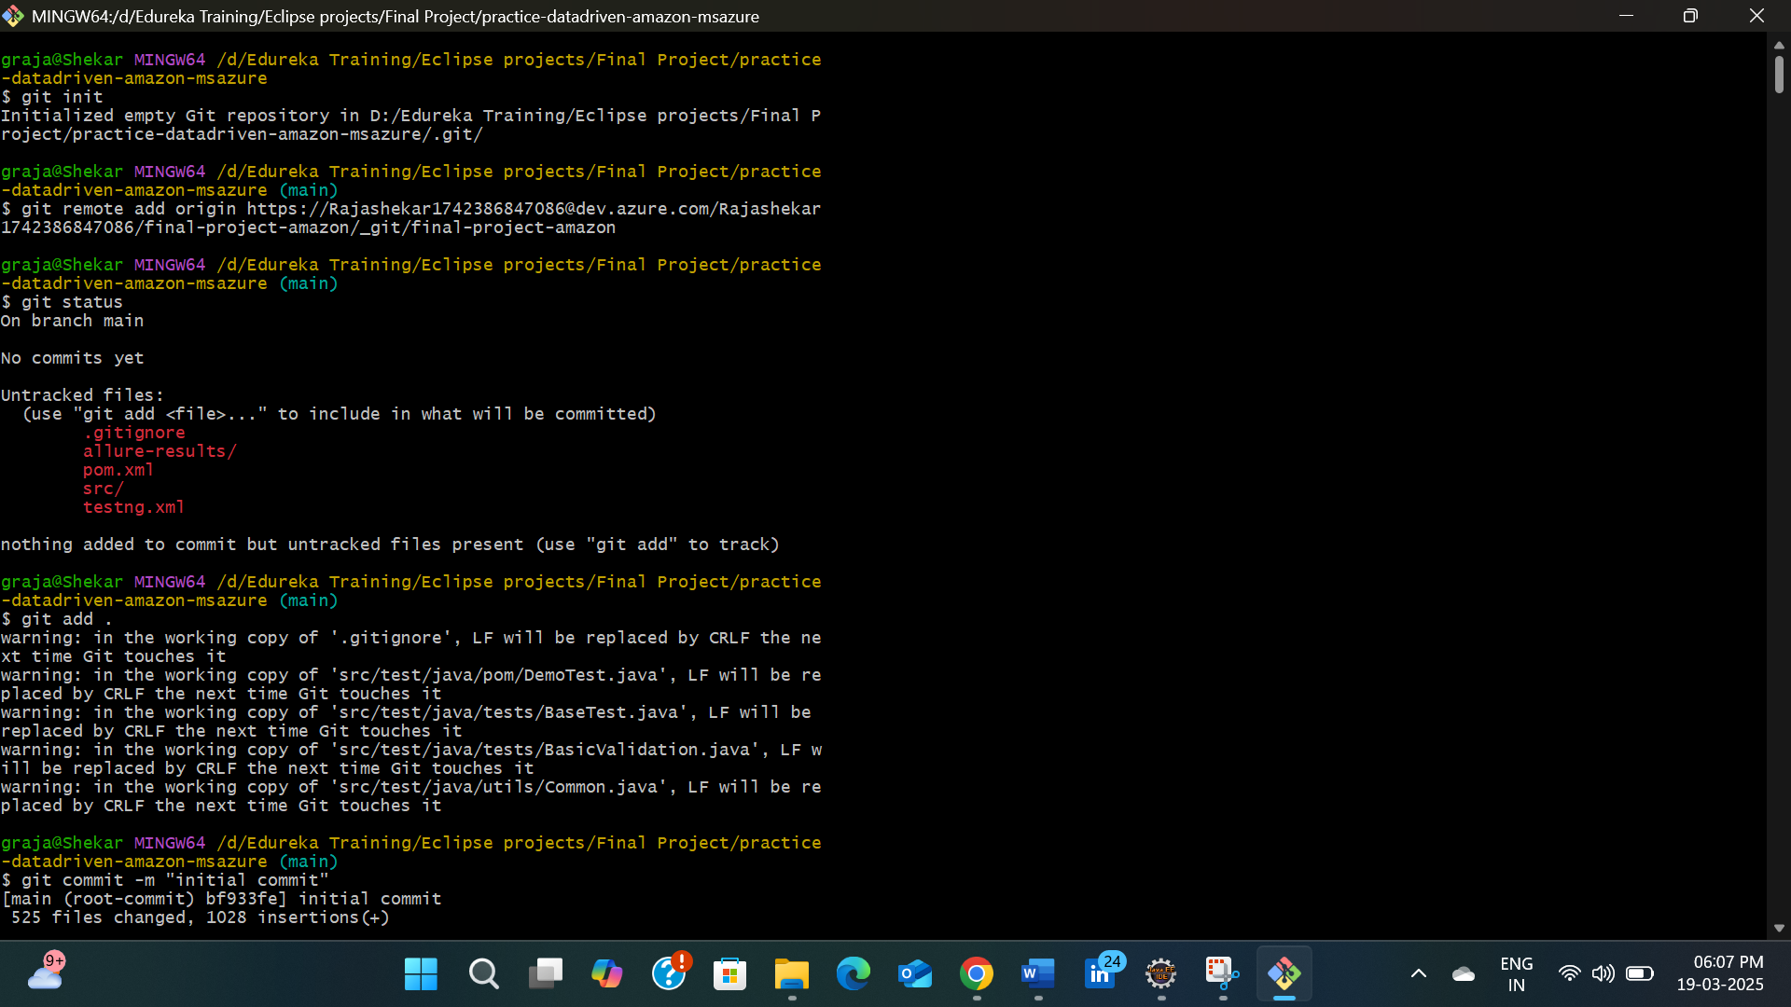

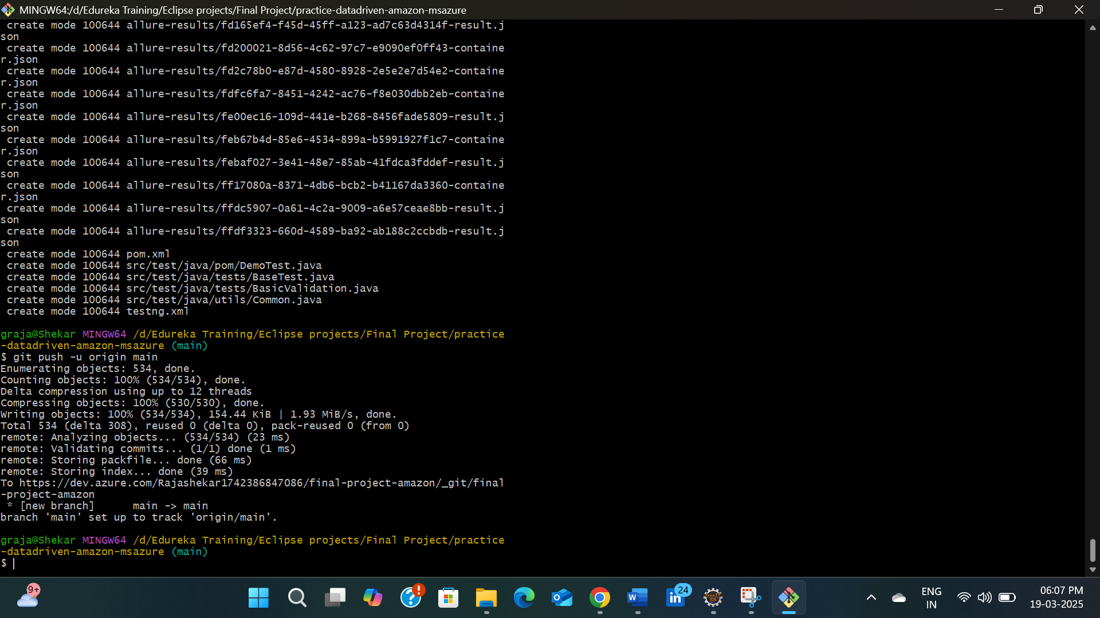

5)Refresh the page to get project

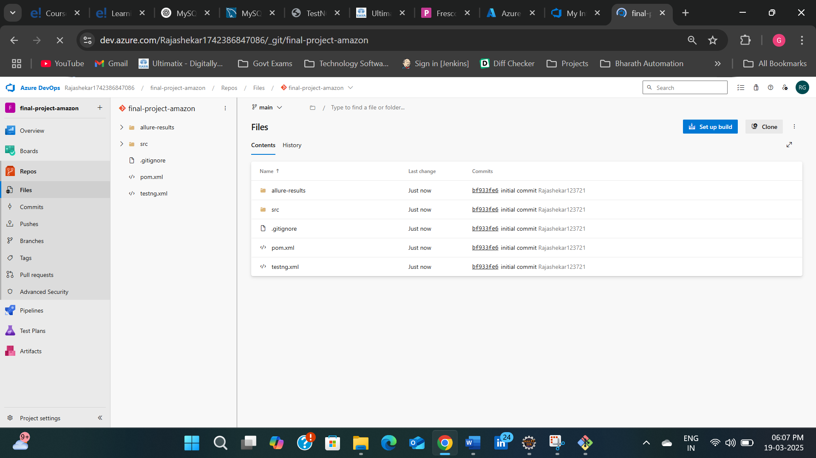

6)Create agent by navigating to Project Settings->Agent pools->Default->Agent.

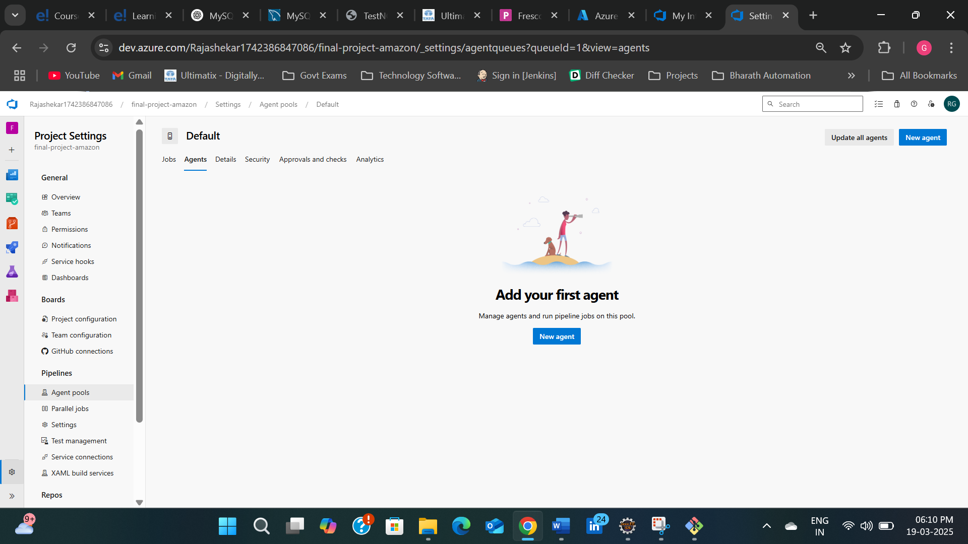

7)Click on download the agent

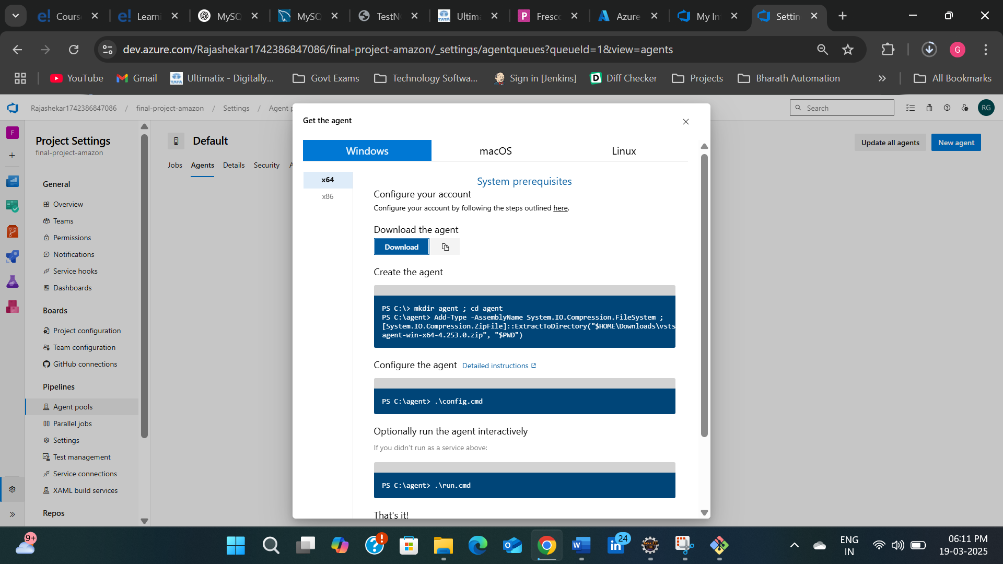

8)Go to Personal access token as shown in below screenshot

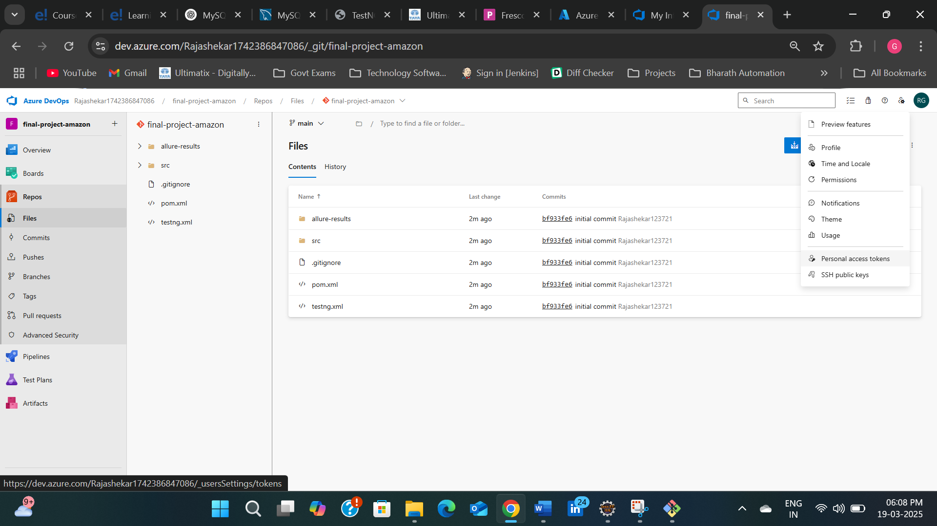

9)Create new personal access token and copy the code which was generated.

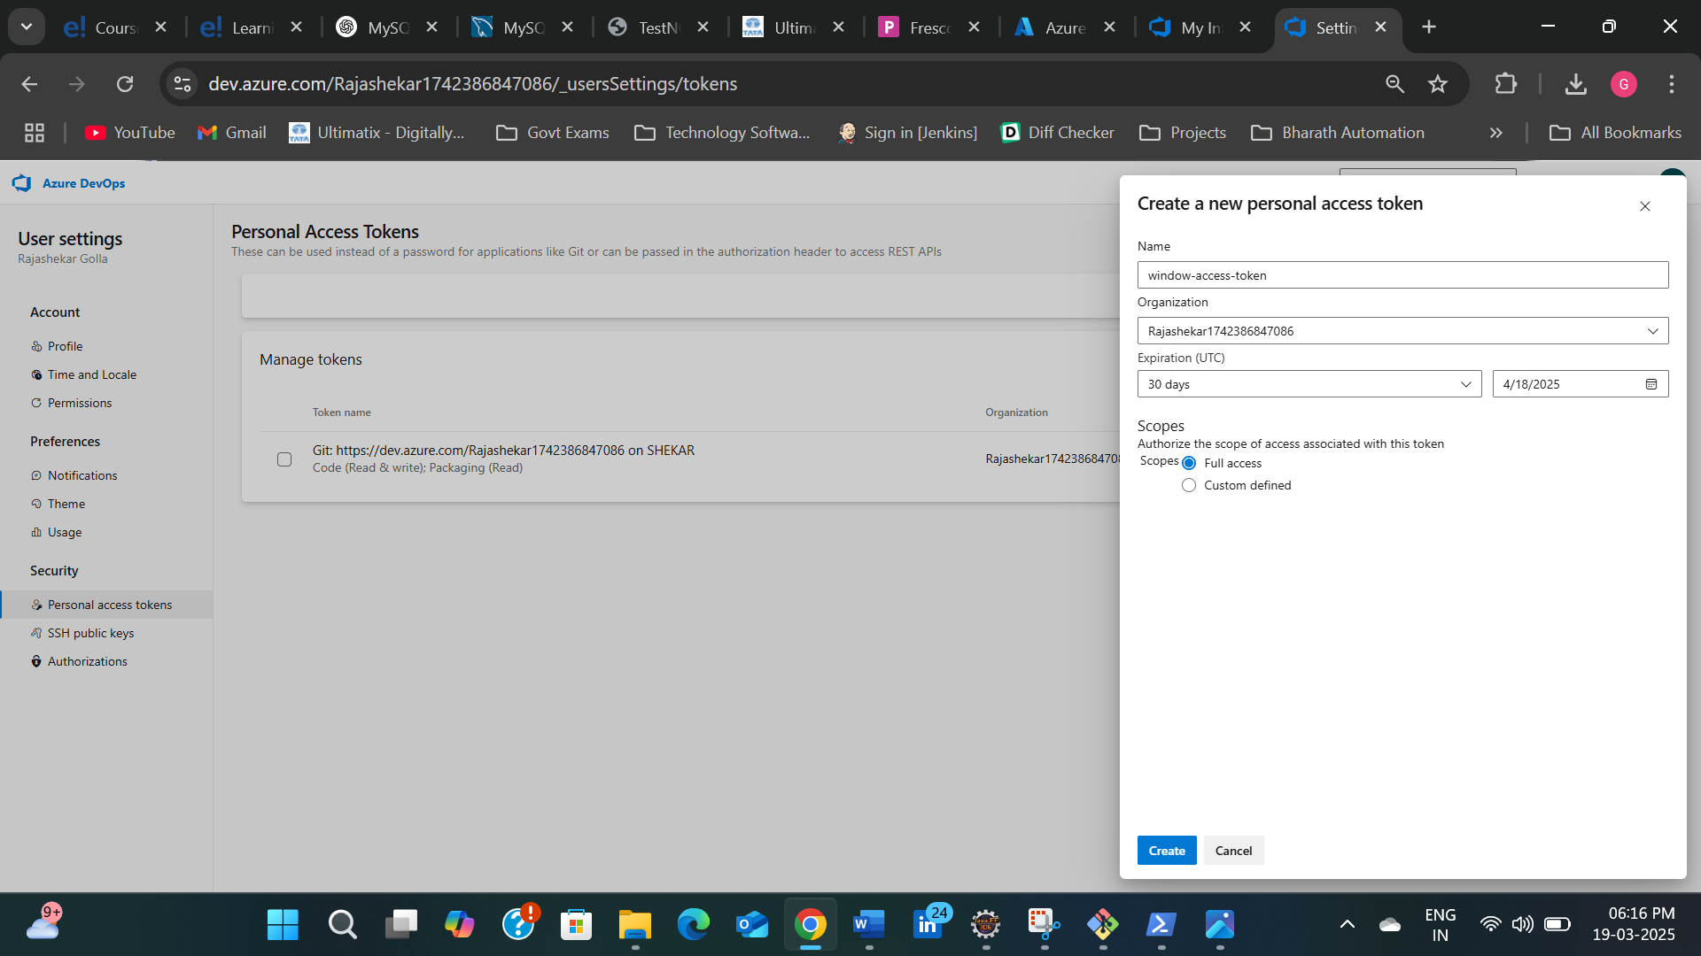

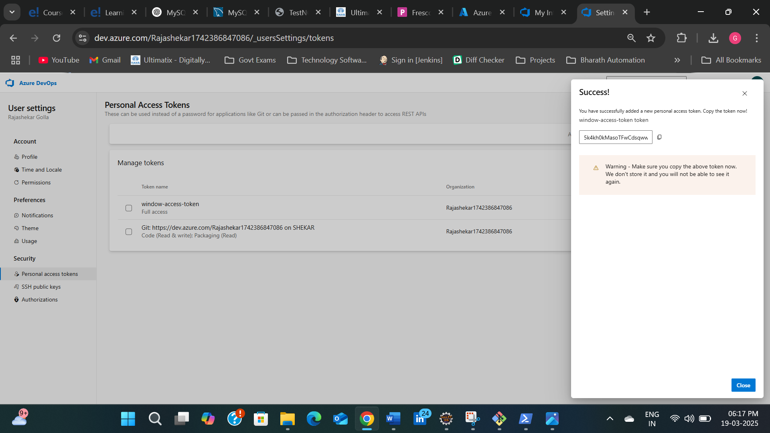

10)Open Windows Powershell as an administrator.

11)Change the directory to the file which was downloaded before and perform operations as below.

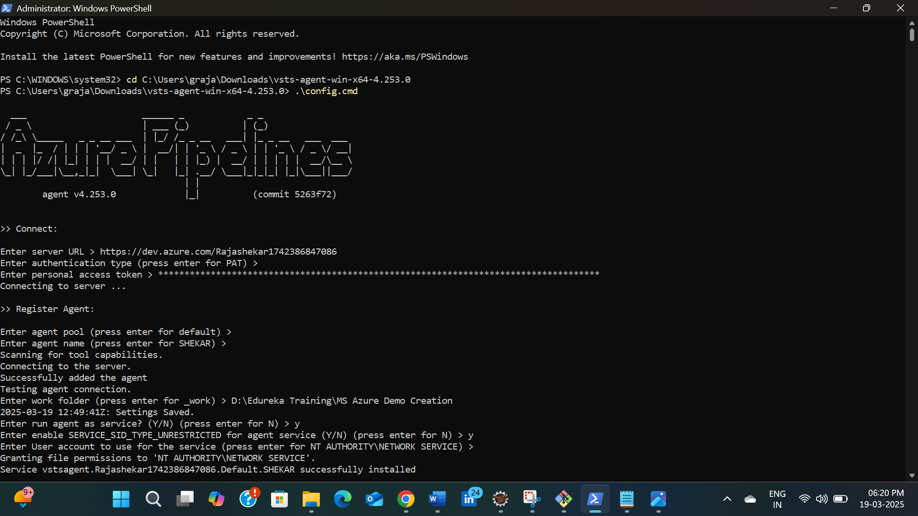

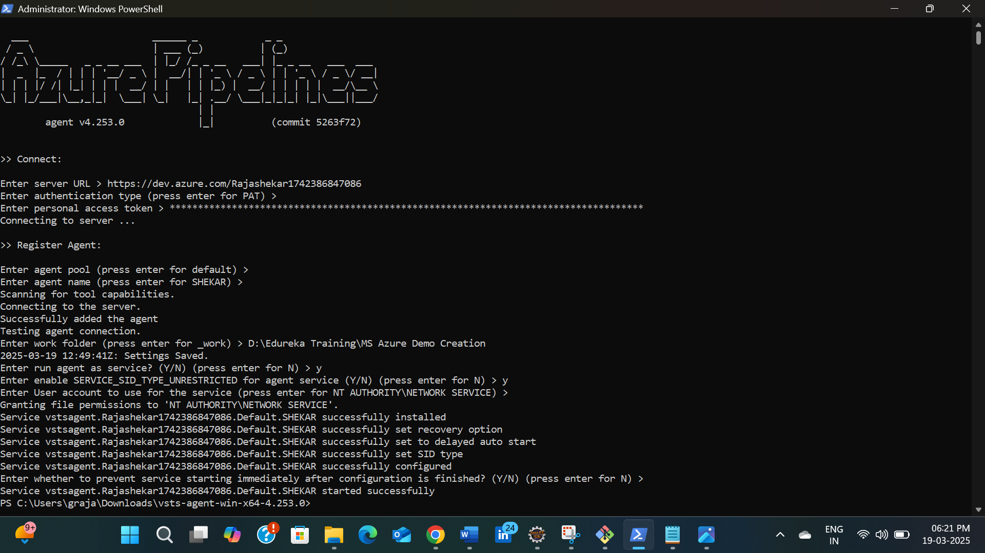

12)Agent is created.

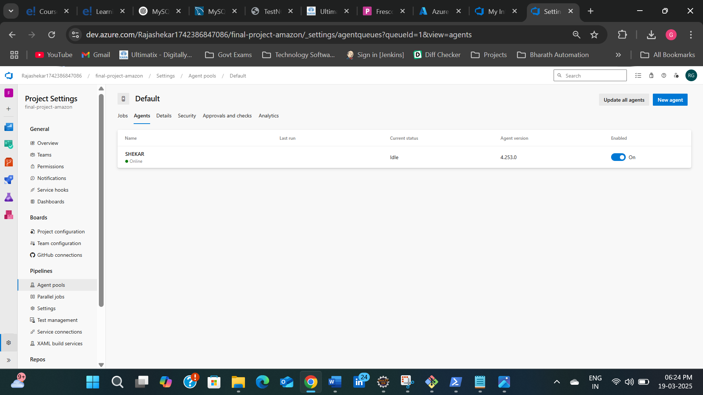

13)Click on set up build and navigate to maven.



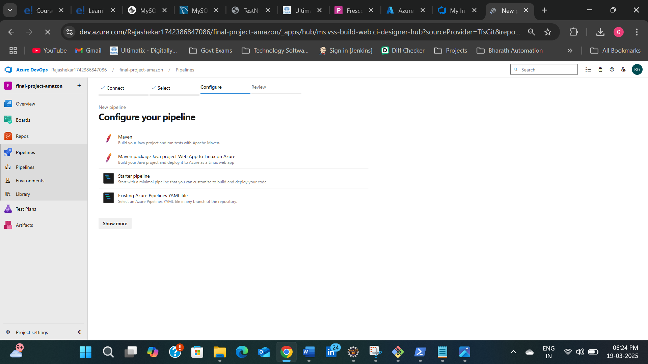

14)Add azure-pipeline.yml file as below and click on save and run.

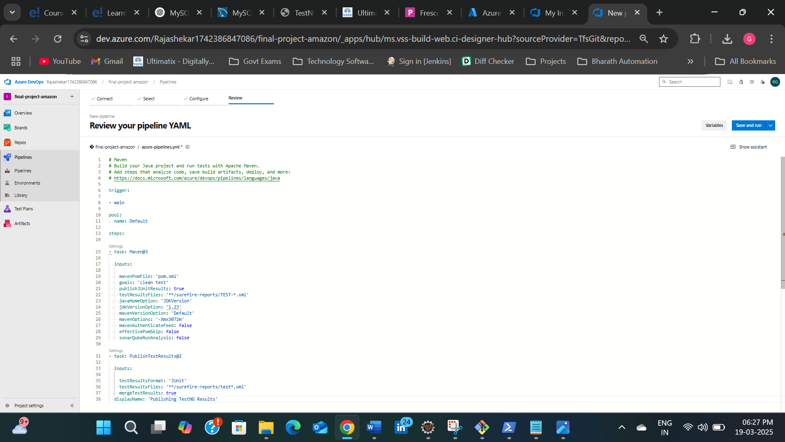

15)Navigate to pipeline and check the jobs.

16)Jobs got successfully passed and check the test results as below.

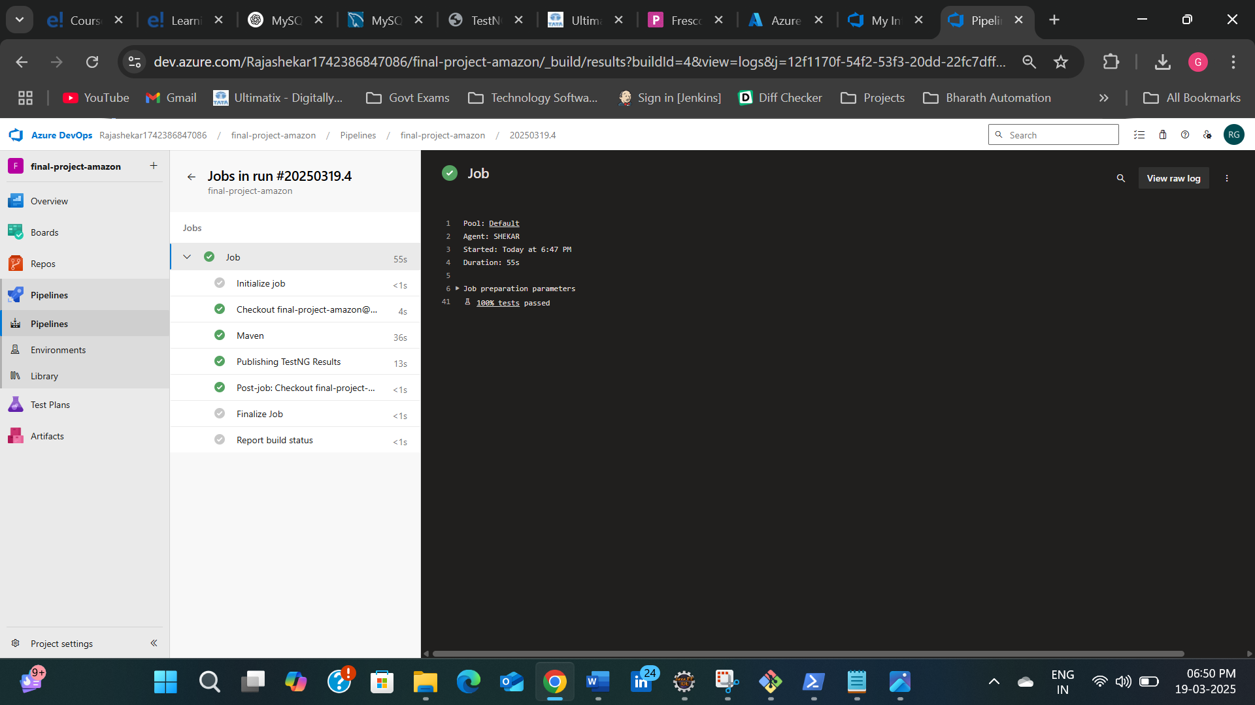

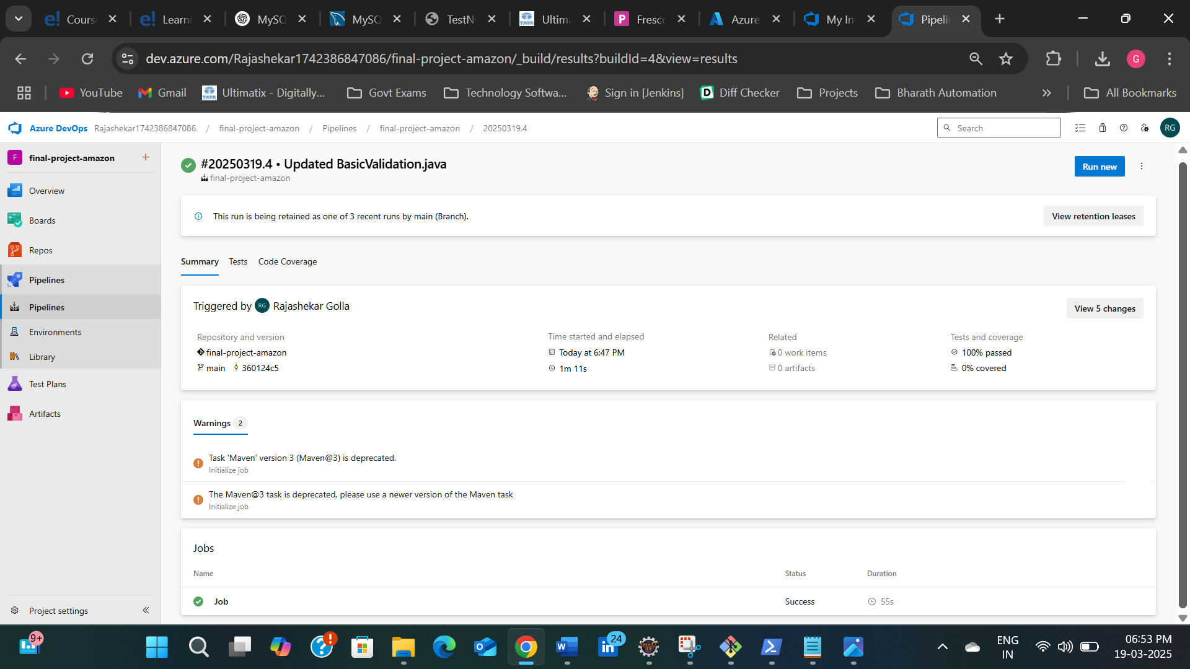

**Test Results:**

